OPERATIONAL STANDARDS & PRINCIPLES
Quality, Environmental & H&S 0.1.1
QUALITY POLICY STATEMENT
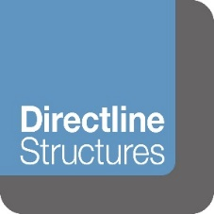

Quality Policy Statement

Directline Structures Ltd is wholly committed to our quality policy and aims to deliver its projects and services to our customers on time and within budget.

We operate a Quality Management System to the ISO 9001 management system standard, including aspects specific to design and development, and the provision of construction projects.

Our organisation is committed to:

- Maintaining a focus on our customers and their needs and expectations
- Continually developing & improving the effectiveness of our Quality Management System
- The enhancement of customer satisfaction

We have a continuing commitment to:

- Ensuring that customer needs and expectations are determined and fulfilled with the aim of achieving customer satisfaction
- Communicating throughout the Organisation the importance of meeting customer needs and all relevant statutory, regulatory & other applicable requirements.
- Establishing and reviewing our Quality Policy and quality objectives
- Ensuring the availability of resources to meet our clients & other stakeholders quality expectations

All personnel undertaking work on our behalf shall understand the requirements of this Quality Policy and abide with the contents of our integrated management system. We shall comply with all relevant statutory, regulatory & other identified requirements, and constantly monitor our performance.

This Quality Policy is regularly reviewed in order to ensure its continuing suitability.

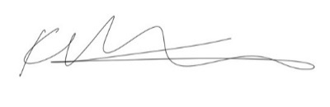
SIGNED:

For and on behalf of Directline Structures Limited

DATE: 21ST December 2021
NAME: K Barker
POSITION: Director

