OPERATIONAL STANDARDS & PRINCIPLES
Quality, Environmental & H&S 0.2.2
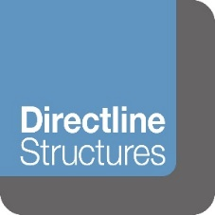
ENVIRONMENTAL POLICY STATEMENT

Directline Structures Ltd is committed to protecting the environment and to complying with all
relevant environmental legislation, regulations and other environmental requirements.

We will regularly evaluate the environmental impact of our activities, products and
services and we will take action to continually improve our environmental performance.

It is our policy to:

- Minimise the use of energy, water and natural resources
- Minimise waste through prevention, re-use and recycling where possible
- Dispose of waste safely and legally
- Avoid the use of hazardous materials, where practical
- Work with environmentally responsible suppliers
- Prevent environmental damage & pollution and to minimise nuisance factors such as noise and air pollution.

We will define environmental objectives, targets and improvement actions that are
related to this policy and to our significant environmental aspects. We will regularly
evaluate progress.

We are committed to providing relevant environmental training and promoting
environmental awareness to employees and, where appropriate, to suppliers and to
communicating our environmental performance.

We will implement processes to prevent environmental non-conformities and to ensure
that we are prepared to deal with potential environmental emergencies.

This policy will be regularly reviewed and updated to take account of organisational
priorities and changes, environmental legislation and best practice.

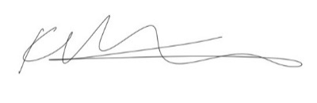
SIGNED:

For and on behalf of Directline Structures Limited

DATE: 8TH February 2022
NAME: K Barker
POSITION: Director

